Alex Sutherland and Justin Tyner

1:

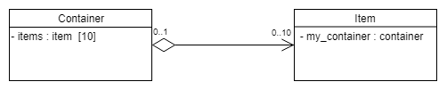

2:

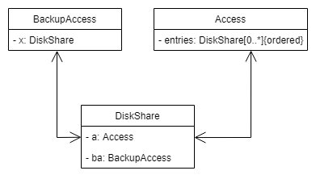

3:

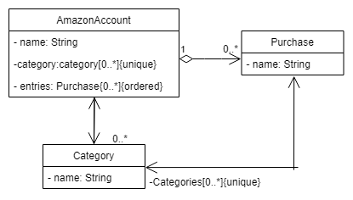

4:

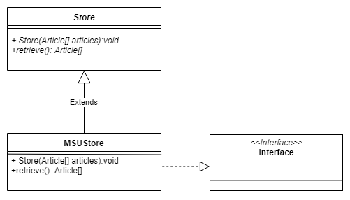

**Exercise part B:**

**Public** class Company{

**Public** String name;

**Public** Address headquarters;

**Public** Employee employee;

**Public** Customer customer;

**Public** VehicleRentalService service;

**Public** Motorbike motorbike;

**Public** Car car;

**Public** Truck truck;

}

**Public** interface IRentable{

**Public** void rent();

}

**Public**  abstract class Vehicle implements IRentable{

}

**Public** class Truck extends Vehicle{

**Public** UnlimitedNatural weight;;

**Public** UnlimitedNatural power;

**Public** String manufacturer;

**Public** String regNo;

}

**Public** class Car extends Vehicle{

**Public** CarKind kind;

**Public** UnlimitedNatural noSeats;

**Public** UnlimitedNatural power;

**Public** String manufacturer;

**Public** String regNo;

}

**Public** class Motorbike extends Vehicle{

**Public** MbKind kind;

**Public** UnlimitedNatural cylinderCap;

**Public** UnlimitedNatural power;

**Public** String manufacturer;

**Public** String regNo;

}

**Public** abstract class Service{

**Public** Customer customer;

}

**Public** class VehicleRentalService extends Service{

**Public** Customer customer;

**Public** Vehicle vehicle;

**Public** void offerCar();

**Public** void offerMotorbike();

**Public** void offerTruck();

}

**Public** abstract class Person{

**Public** String name;

**Public** String email;

**Public** Address address;

}

**Public** class Employee extends Person{

**Public** String name;

**Public** String email;

}

**Public** class Customer extends Person{

**Public** String name;

**Public** String email;

**Public** BankAccount bankaccount;

}

**Public** class Subcontractor extends Customer extends Employee{

}

**Public** class BankAccount{

**Public** UnlimitedNatural number;

**Public** String depositor;

**Public** String bank;

}

**Public** class Address{

**Public** String street;

**Public** String postalCode;

**Public** String city;

}